**4.password encoders**

How our passwords validated with out PasswordEncoders

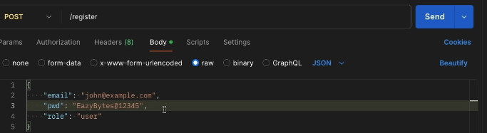

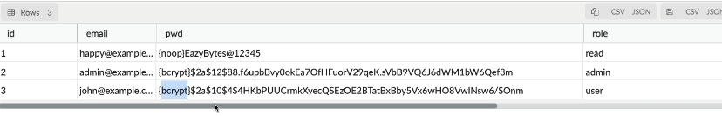

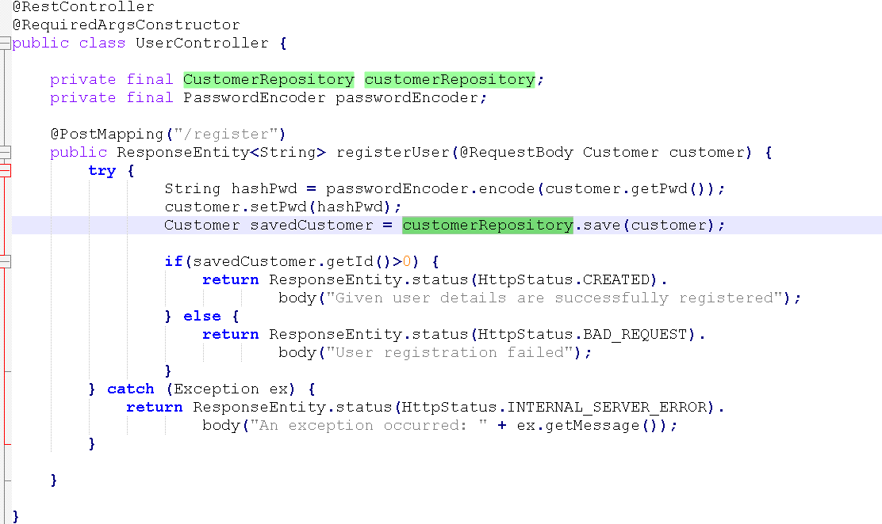

What is Encoding, Decoding & why it is not suitable for passwords management

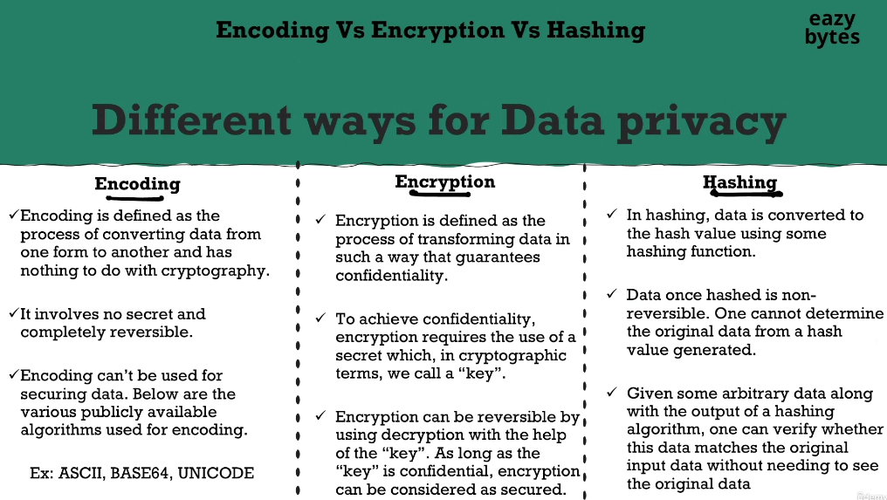

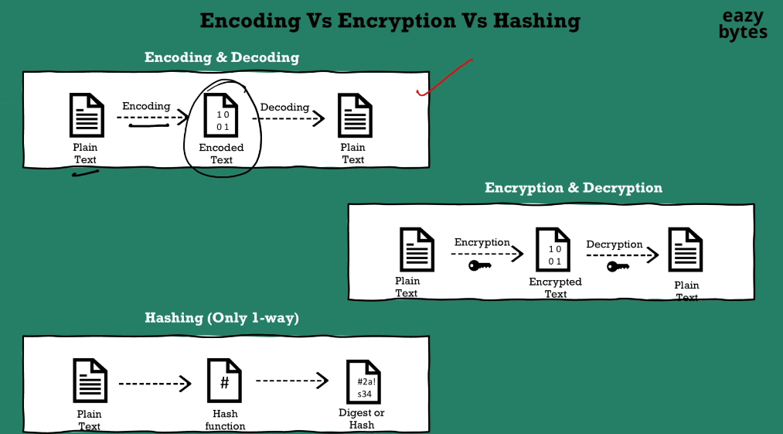

Then with that you may have question which is, under which scenarios people uses the encoding and decoding process?

Whenever a system is not capable of dealing with the binary data for all such scenarios, encoding and decoding is going to be used.

For example, think like there is an Outlook application.

We know Outlook is an application which is going to help us to send the emails and to receive the emails, inside the mail applications they're not capable of storing

or dealing with the binary data like image, videos, so whenever we try to send these type of files as an attachment, since these mail applications, they're not capable of processing the binary data behind the scenes, what is going to happen is,

all these binary data, it is going to be encoded with the help

of formats like BASE64 encoding.

Once the encoding process is completed, these files, they're going to look like normal text to files.

So on the other side, whoever is trying to receive these data, on their side the decoding process is going to happen. So from the encoded value,

they are going to derive the original binary data, which is an image or video.

So there are many use cases around encoding and decoding inside the industry.

What is Encryption, Decryption & why it is not suitable for passwords management

Most of developers, they assume encryption is the right option

for the passwords management. If you're under the same assumption, you are wrong, encryption is not the right option.

How this confidentiality is going to be assured?

Whenever someone is trying to encrypt a plain text value, they're going to use a secret along with the encryption algorithm.

In cryptographic terminology, we call these secret as key.

Once the encryption is completed, it can only be reversed by using the same algorithm, and the same secret key.

As long as someone take care of securing their secret key and make sure that no unauthorized person can get this key, then we can assume that encryption is a safety process.

But still, this is not a recommended approach for passwords management because some person has to generate the secret key, as some application has to generate the secret key very first time during the encryption process.

If the person or if the application, which is trying to generate the secret key,

if they lose the secret key, then there is no security or confidentiality in the encryption process.

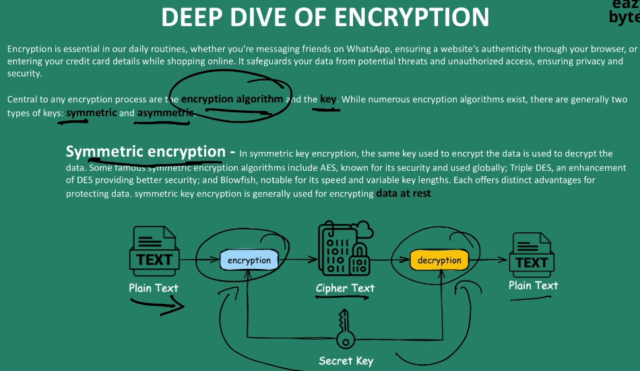

There is a drawback with the symmetric encryption, though it is trying to provide the confidentiality,

if someone lose the secret key to unauthorized persons, then they should be able

to do both encryption and decryption.

That's why in this scenario, the strength of your encryption depends upon

how strongly you are protecting your secret key.

And, to some extent, you can also use the symmetric encryption if there is only a single application use involved.

Don't try to use a symmetric encryption if there are multiple parties involved during the encryption and decryption process.

Even if one of the third party application is compromised, then your encryption is going to be useless.

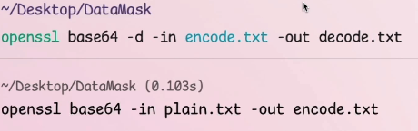

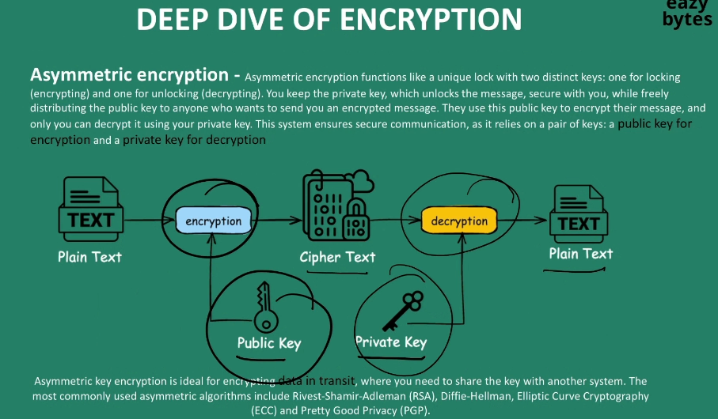

Let's go to the asymmetric encryption. Inside asymmetric encryption, we are going to have two different keys. The very first one is public key, the other one is private key.

Whenever someone want to initiate the encryption process, what they are going to do is the owner who is trying to initiate the whole encryption process, they are going to generate two types of keys. The very first one is public key, and the second one is private key.

The owner, they will keep the private key with themself, and they will distribute the public key to any number of third party applications.

So whoever has this public key, they will be able to perform only the encryption.

So once this encryption is completed, the cipher text is going to be received

by the owner who initiated all this encryption process. So the owner during the decryption, they have to use the private key to decrypt the data to plain text.

They can't use a public key for the decryption process.

That means anyone can generate the encrypted data with the public key, but the decryption process can be done only by the owner who owns the private key.

So this is one style of encryption.

Since there are two different types of keys are being used here, we call this approach as asymmetric encryption. This asymmetric encryption is ideal for encrypting the data in transit.

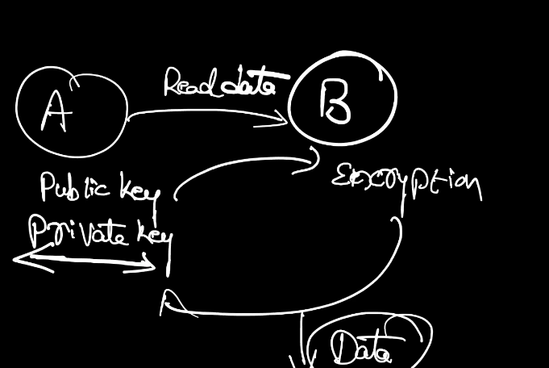

Why can't we use encryption for passwords management?

Our application can make sure that no one is stealing the secret key,

that can be your assumption, but in reality, it is not going to work that way.

You may have people inside your organization only who is looking to steal your secret key.

That's why though these encryption option is providing confidentiality option,

it is not providing the integrity option.

You can't guarantee that no one can steal you a secret keys or private keys.

If someone steals your keys, then all the encrypted data can be easily decrypted by them.That's why we should also not consider the encryption process for the password management.

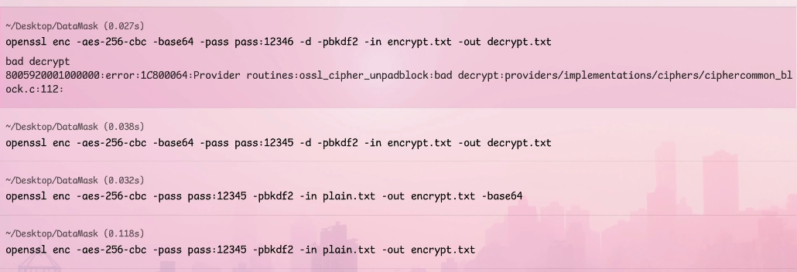

The purpose of this pbkdf2 is it is going to make your encryption more stronger.

So instead of directly using this 12345 as a secret key, behind the scenes,

what it is going to do is based upon the password that we have provided,

it is going to add a random (indistinct) to derive another internal secret key.

I'm going to discuss what is a (indistinct) in the upcoming lectures.

Since the secret key is going to be derived based upon the password that we're trying to provide, this process, they call it as pbkdf2.

Pb means password based, k means key, d means derived, and F2 means function two.

 Introduction to Hashing

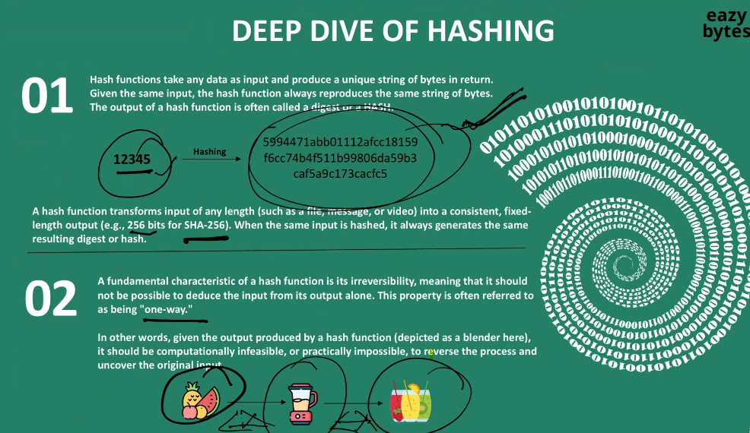

Whenever you use the hashing, regardless of whatever amount of data

that you're trying to as an input, you're always going to get a fixed set of hash value.

Here I'm trying to give 12345 as a input, and this is how the hash value is going to look like. The length of the hash value for 12345 are, if I try to give a input length of one GB data, even in such scenarios also, I'm going to get the same hash value length. I'm talking about the length but not the content.

For example, if you use the SHA-256 hashing function, you're always going to get the output hash value with the 256 bits.

Whenever you are thinking about hashing, always remember the blenders

that we use on our day-to-day life.

Let's try to understand why I'm trying to compare hashing with the blender.

To the blenders, think like you're trying to give the input, which are fruits.

So if you try to provide these fruits as the input to the blender, you are going to get juice as an output. Now, if I give the same juice to the blender back, will I get the fruits? Off course not, because it is irreversible process.

The same property applies for hashing also, so hashing is always one way.

It is not possible to reverse the hashing.

Let me show you the demo of hashing with the help of OpenSSL commands.

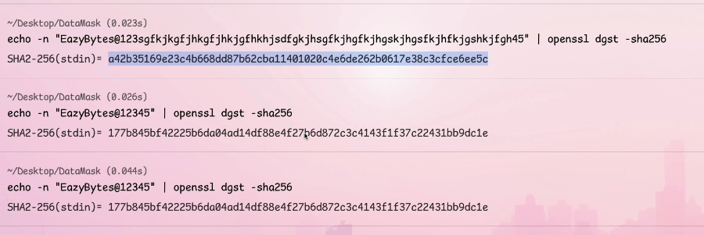

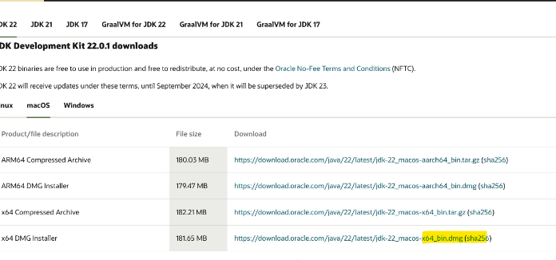

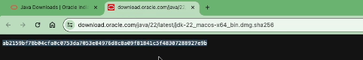

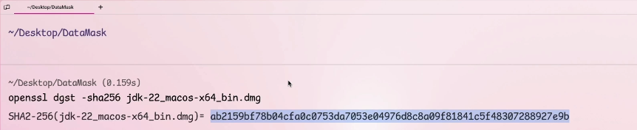

You can see it is matched perfectly.

This gives an assurance to me that whatever I downloaded it is an original file and there is no tampering done.

Drawbacks of Hashing & what are Brute force attacks, Dictionary or Rainbow tab

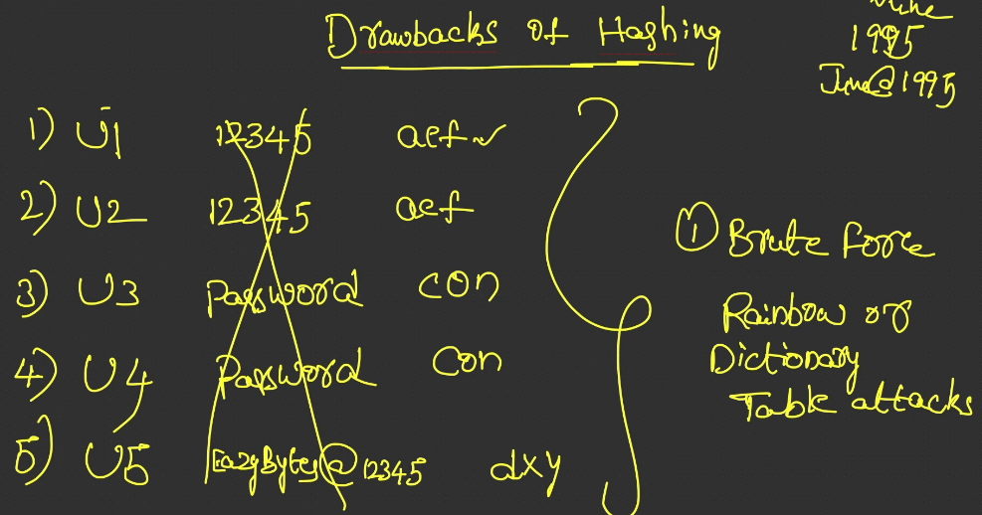

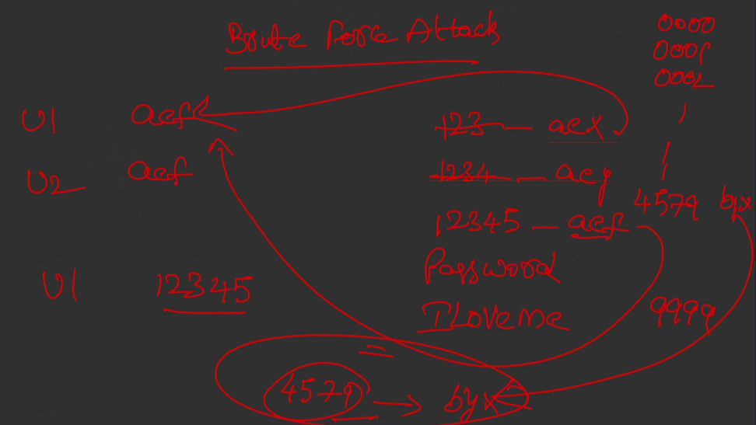

The hacker is going to calculate the hash value by taking all the most commonly used passwords. So think like the hacker started the hashing process

in his own system for all the simple passwords. First, he will try to check what is the hash value for 123. And he will check for 12345, and he will get aef.

So here, the technique that the hacker is using is, he's trying to perform Brute force attack by taking all the possible combinations, or by taking all the simple passwords

or most commonly used to passwords.

And this technique, it is going to be more dangerous in the scenarios like ATM PIN or credit card PIN. We know the ATM PIN or credit card PIN, it is going to be like four-digit number or six-digit number.

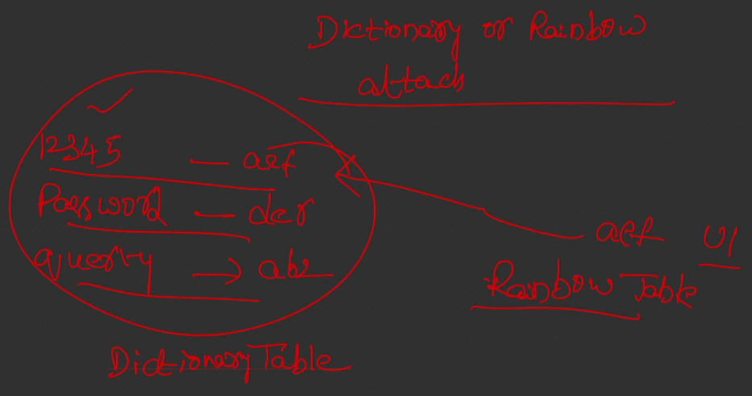

Now, let's try to understand how the dictionary attack or rainbow table attack is going to happen. In this attack, what is going to happen is, the hacker

or the attacker is not going to strain himself by calculating the hash values

once the data breach is completed.

Instead, he's going to prepare a table with the most commonly used passwords,

like 12345, password, qwerty. So fo these kind of passwords, he's going to maintain a table like this is the hash value for it, per passwords, the hash value, let's assume it is der, and for the querty, the hash value, let's assume it is ab2.

So this way, he's going to have a ready made table with all the possible combinations of a password. So the password can be a most commonly used password

or it can be a weak password or it can be a possible combination of all the characters. He's going to have millions and millions of records

inside an table with the pre-calculated hash values. So these kind of tables, we call them as dictionary tables.

So inside the dictionary table, for each record, there is going to be an entry inside the table. With that, the hacker may end up having the billions of records inside the table.

And the more number of records he's going to have, the searching is going to take some time. And he also need lot of storage to store all these records.

So to make use of the space efficiently and to make his life easy, he's going to prepare some advanced version of dictionary table, which is rainbow table.

So we discussed one drawback, which is hashing is always going to give you

the same hash value if the input is same. So due to these drawback, these attacks are possible, which is brute force attack and the rainbow or dictionary table attack.

The next drawback of the hashing is it is super fast. If you give 1GB file as an input,

or if you give file letter characters as an input, it is always going to give you the hash value within nano or within milliseconds. So due to the super fast nature, hackers, they are able to perform the attacks like brute force attack.

The hackers are able to calculate hash value for various combinations of the letters.

And indirectly, they are able to identify what is the original text value.

So these are the major drawbacks.

The very first one is it is always going to return the same value after the hashing process. And the second one is the hashing function, they are super fast in nature.

How to overcome Hashing drawbacks, Brute force and Dictionary table attacks

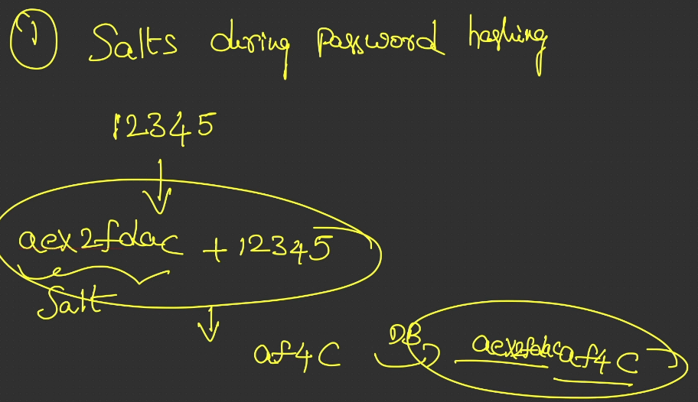

So please note that this is that total hash value for the combination of salt and password. Along with the hash value, they will also store the what is the salt they have used during the hashing process.

So this is the total value that is going to be stored into the database.

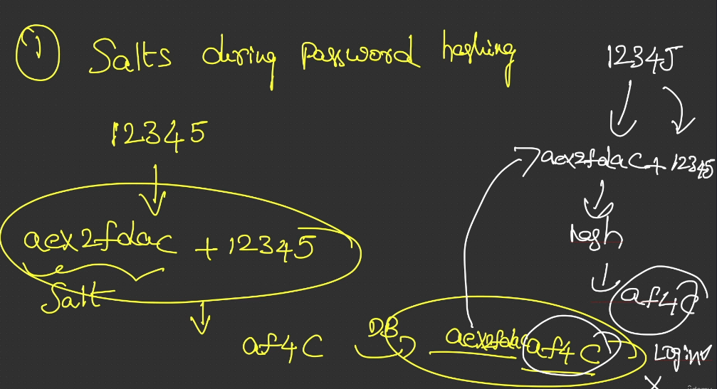

What is advantage that we are getting if we try to add the random salt value?

The purpose of adding these random salt value is, even if one of the other user has the same password, which is 12345, for him, the salt value is going to be different.

Though the password is same, the overall hash value is going to be the different value. **The reason is the salt value, which is going to be randomly generated**

**for each and every user**.

With this, each and every user inside your database, they are going to have their own unique hash value. Their passwords can be same, but their hash value is going to be unique because due to the different salt values we're trying to use.

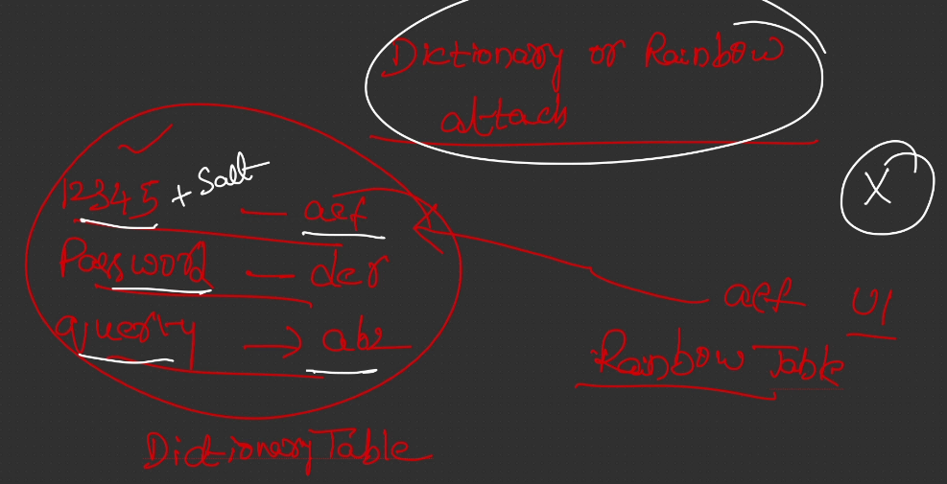

Now, with this, let's try to understand how the problem of rainbow attacks or dictionary attack and brute force attack is going to be solved.

With the salt solution that we have discussed so far, the hacker can't use the rainbow tables or dictionary tables that he has built behind the scenes.

The reason is very simple.

He will only have the hash values for the plain text passwords are for the simple passwords. He can't guess the what is the random salt value that each user is going to have before the data breach.

The purpose of these tables is he's going to prepare these tables before the data breach itself so that his job of cracking the password is going to be fast.

But with the salt value that we are going to add for each and every user,

though he have these dictionary or rainbow tables prepared, he can't use them.

These tables are going to be useless because the hacker can never know what is the salt that we are going to add to these 12345.

Maybe he will come to know once the data breach has happen and once the hacker checks the database value where we are storing the salt to place hash value.

So with this, these attacks we are trying to avoid.

Now, let's try to understand how the brute force attack is going to be avoid.

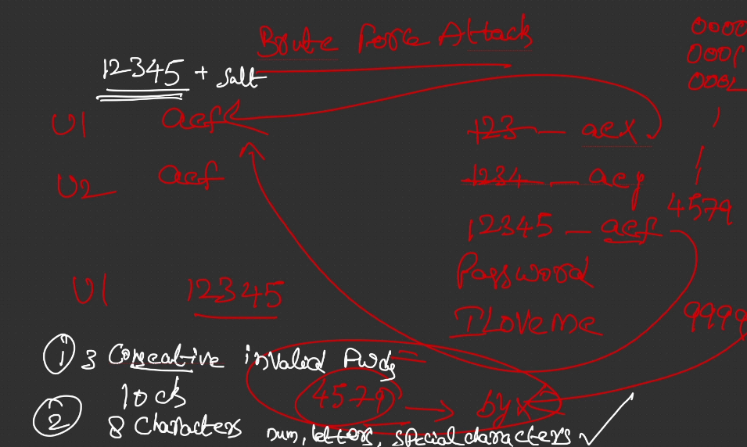

Brute force attack is going to happen in two types of scenario.

The very first scenario is the hacker don't have the original hash value of the end user, he just want to hack into someone's account.

He will keep on trying some random passwords or some simple passwords, which is 12345, or any other simple passwords, or he will keep on going to try various passwords using the UI application or using whatever mechanism that application is going to expose.

In this scenario, the salt is not going to protect us because during the login operation, the backend API, it is going to derive the salt value from the value that we stored inside the database column and up into the value entered by the hacker

inside the UI application.

Think one of the scenario where the hacker gets the user1 password,

which is 12345 correctly, and he entered this password onto the UI.

And behind the scenes, the backend is going to leverage the salt value

and up into this user-entered value, and it is going to generate the overall hash value

and the hash is going to match. Here, the salt is not protecting

from the brute force attack.

So to avoid these kind of brute force scenarios,

organizations, they are going to have various approaches.

The very first approach is as soon as they detect someone entered

three consecutive invalid passwords, they are going to lock the account.

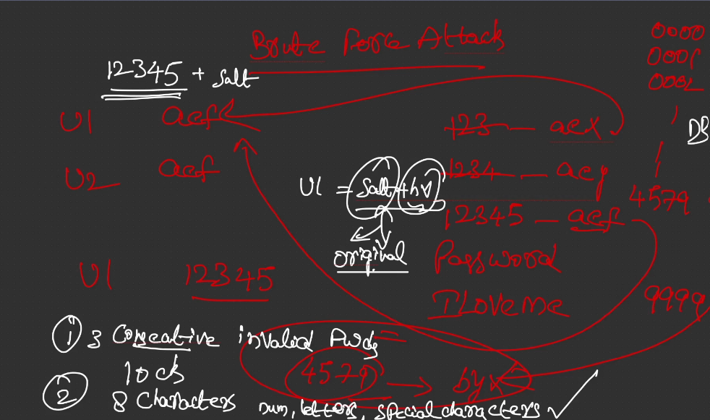

The second scenario is, think like the hacker steal all the data present inside your organization DB. It has all the hash values of all the users.

So for user1, think like the hash value stored inside the database is salt plus overall hash value. So this is the value stored inside the database.

So from this value, the hacker easily will know what is the salt value,

he just have to guess the what is the original password. So if he can able to guess these original password, he will apend this original value to the salt value to get the overall hash value and compare with this.

So in this scenario, the salt is not protecting us.

So there is one more solution which we need to implement to protect from these kind of scenarios.

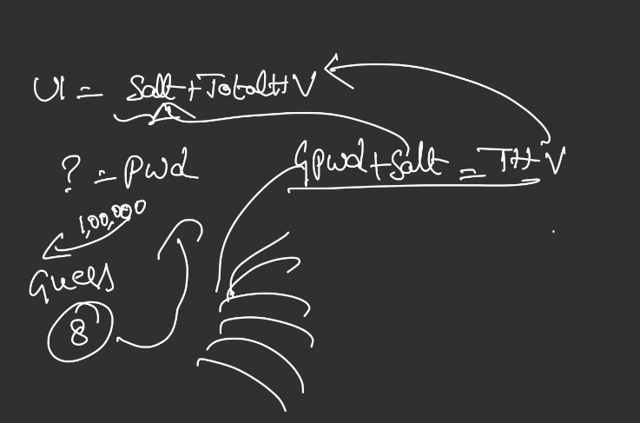

Before I try to explain that solution, let's try to think what is going to happen

whenever hacker is trying to guess some password.

So for user1, inside the database, we have salt plus total hash value.

So now the hacker knows the salt but he don't know the password.

So to know this password, he's going to do lot of guesses.

So sometimes these guesses can be in millions because in order to guess

an eight-character length password, which is a combination of letters,

special characters, and numbers, he has to try with the millions of combinations.

So for each combination, he has to follow the process of what is a guessed password. So I'll just mention G here, guessed password, and plus salt value that he get from the database.

So the total hash value, he will try to compare with this.

So this operation, he has to perform for all the millions of guesses

or thousands of guesses he's going to do. And this is not going to be a problem for him because the hash function is super fast.

He can try to guess all the combinations by taking some one week time

or by taking some one month time because the hash functions are very fast.

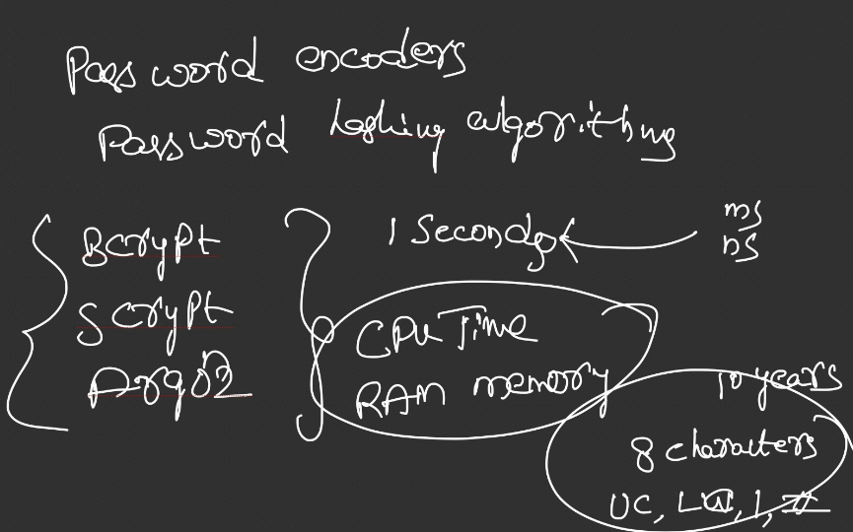

So to overcome this challenge, we need to make the hash functions intentionally slower.

By default, the hash functions are fast, we know that, but to fix this issue, we need to make it slow.

So how to make these hash functions slow?

It's very easy. Inside the industry, there are some password encoders

or password hashing algorithms.

We need to use those algorithms only, hashing algorithms.

For example, Bcrypt is one such algorithm, and Script is another algorithm,

and Argon2 is another algorithm.

So these are all the password hashing algorithms or the password encoders that industry recommends.

So when we use these hashing algorithms, so what is going to happen

is they are going to intentionally slow the process of hashing.

For example, for each hashing that you want to perform, they are going to take intentionally one second. So previously, if you try to use a simple hashing passwords,

the hashing is going to complete within millisecond or nanoseconds,

but right now, we slow them by bringing two seconds.

If needed, we can tune these algorithms to slow the hashing process for two seconds or three seconds based upon your business requirements.

Apart from the slowing the hashing process, these password hashing algorithms,

they are going to demand lot of CPU time and they also require lot of RAM memory time. So they're going to make the hashing process more complicated.

So with this setup of slow hashing algorithms, for any hacker to guess a password,

it is going to take at least 10 years.

For example, think like one of the organization enforced to use least eight characters as a password, with the combination of upper case value, lower case value, numbers, and special characters.

So with this combination, if someone choose a password, to guess these password with the slow hashing algorithms, for the hacker, it's going to take a lot of time.

Apart from time, the hacker also should invest millions of dollars to provide the CPU time and RAM memory for the hashing algorithms.

So this is how we are going to prevent the second scenario of brute force attack

where the hacker already know what is the hash value.

But here, you may have some interesting question, which is, if we are intentionally slowing the hashing algorithms by following these password hashing algorithms,

then can't it affect as also the same way?

This can be your question.

No, it is not going to affect the organization the same way.

For example, think like one of the user, how many times he's going to register in his lifetime? He's going to register only one time.

That means for a single user, we need to spend one second time,

and we should provide some CPU time and RAM memory.

And later on, during the login, also the end user, he's not going to log in every second or every minute. Maybe he may log in into the application the same login session he may use for next one hour or for next two hours or throughout the day.

That's why providing these RAM memory, CPU memory, or one second time during the login or during the registration process is not going to affect the organizations

because the end user can wait for one second to log in into his application.

It's not going to give any bad experience.

So what are the solutions that we need to follow to overcome all the drawbacks?

We need to make our hashing algorithms slow. So this is one of the solution.

And the second solution is, we need to make sure we are generating the random salt values during the registration process.

The same salt values we should also store inside the database.

Introduction to PasswordEncoders in Spring Security

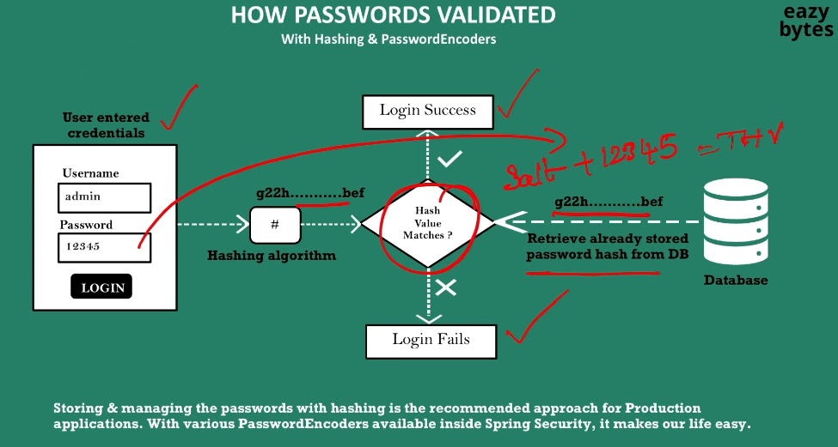

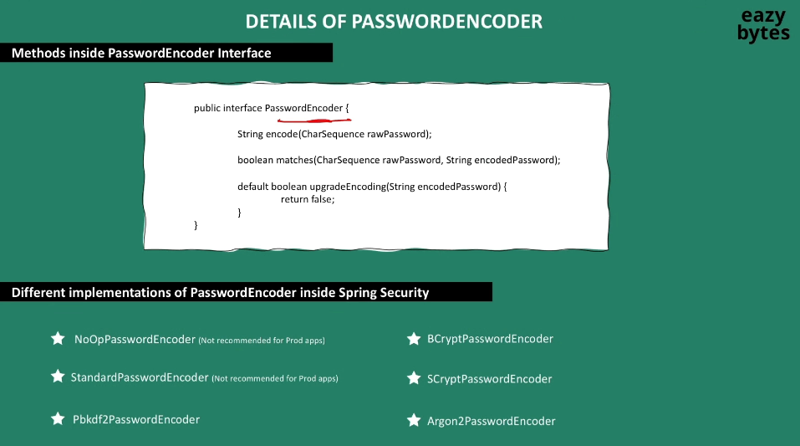

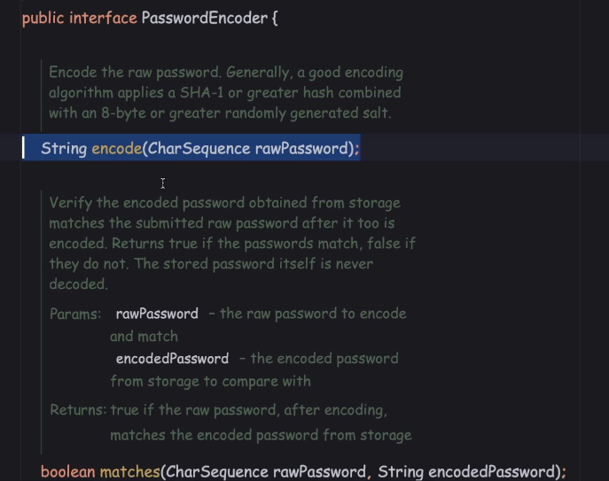

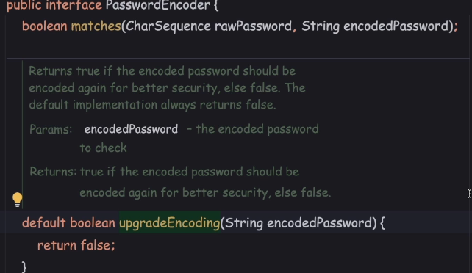

Deep dive of PasswordEncoder implementation classes

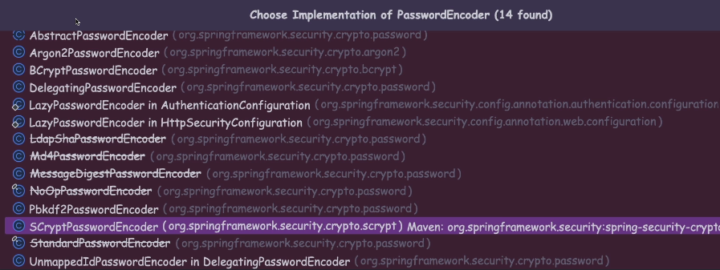

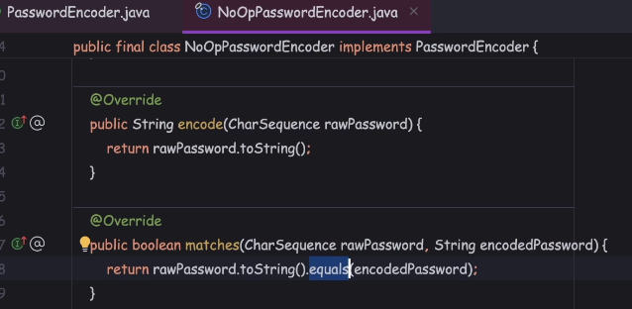

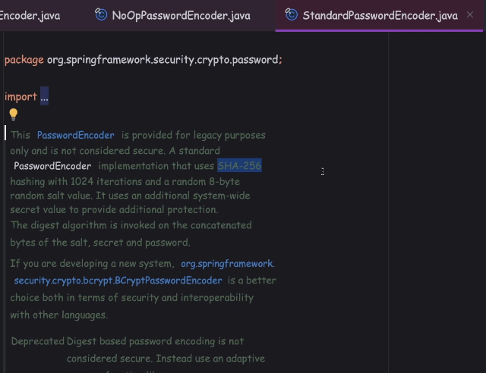

they are saying this PasswordEncoder uses SHA-256 hashing algorithm,

which is going to perform 1,024 iterations with a random 8-byte salt value.

but right now, no one accept these as a strong hashing algorithm,

because due to the advancements happened inside the CPU and GPU systems,

hackers can easily crack the password by using methods like Brute force attack.

In other words, whenever someone uses this hashing algorithm today, it is not going to make the hashing process slow enough for the hackers to not crack the password.

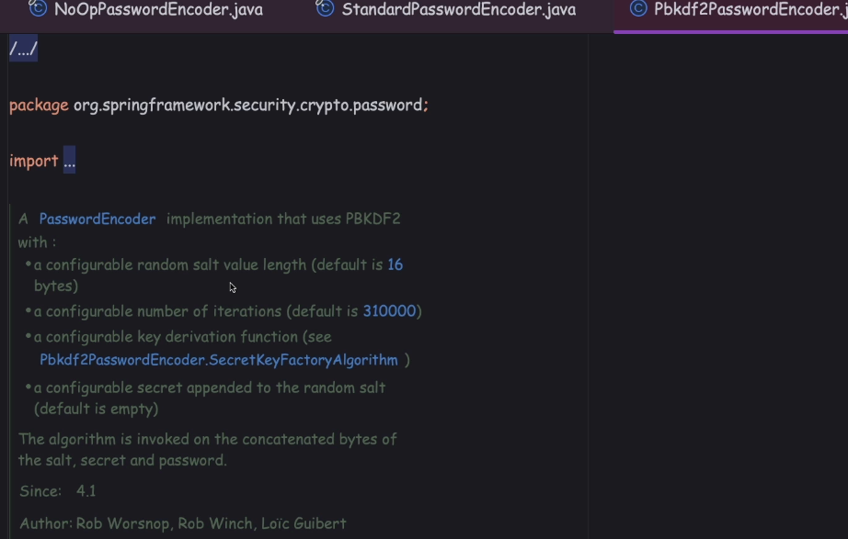

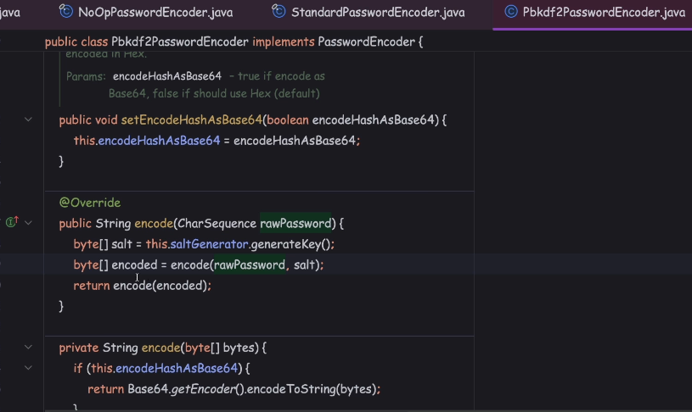

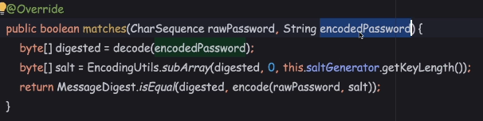

I don't recommend using this password encoder, because, this password encoder,

strength only depends based upon the secret that you provide,

and based upon the function that you are going to provide.

So it is putting an extra burden on top of the developers to provide a secret and function.

On top of that, this is an old hashing algorithm, we have more advanced hashing algorithm, like BCrypt, SCrypt, and Argon2 came into picture.

That's why we don't use this inside the production applications.

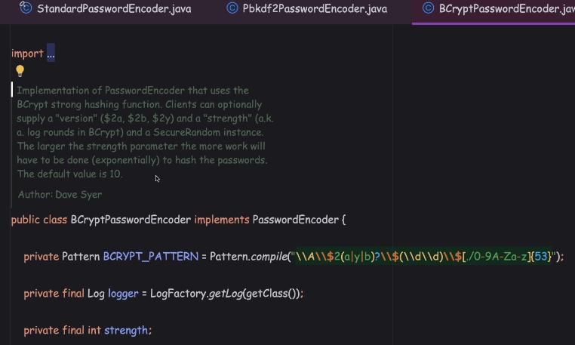

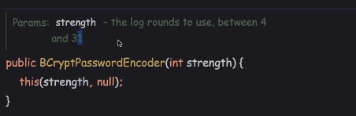

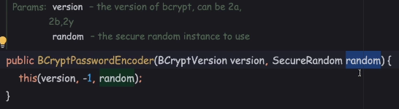

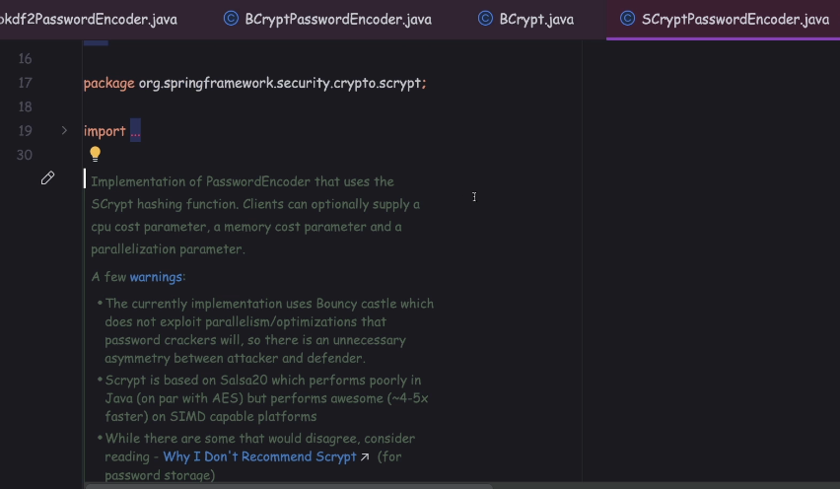

So, SCryptPasswordEncoder is an advanced version of BCryptPasswordEncoder.

The specialty of SCryptPasswordEncoder is it is going to leverage the SCrypt hashing function, and whenever someone is using this hashing function,

we can configure CPU cost, memory cost, and the parallelization.

With these configurations, we can make hacker life tough, because the hacker has to provide the CPU computation, by having a high-end machine.

Apart from that, you should also have lot of RAM to support the memory cost,

and, based upon the parallelization parameter, the hacker should also support parallelization execution, or multi-threading execution.

So, with these three parameters, these SCryptPasswordEncoder

considered more stronger than BCryptPasswordEncoder.

**I'll come to the point that why Spring Security team are recommending to use a BCryptPasswordEncoder.**

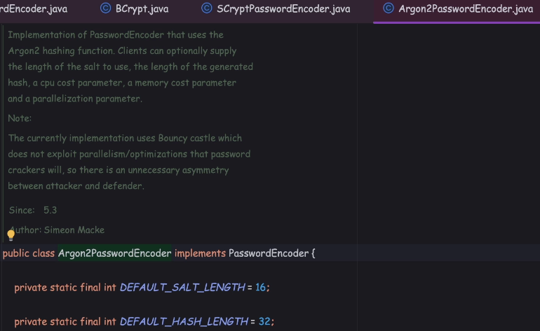

The next PasswordEncoder we have is Argon2PasswordEncoder.

So, a few years back, there is a competition happened in the industry

to identify which hashing algorithm is the winner.

In that competition, the winner is Argon2.

Argon2 hashing algorithm is the latest hashing algorithm, which is an advanced version of SCrypt hashing algorithm.

This also allow you to configure CPU cost, memory cost, and parallelization parameter.

The way that SCrypt and Argon2 work, it is almost similar, just that Argon2 is the latest version, and it handles the drawbacks of a SCryptPasswordEncoder.

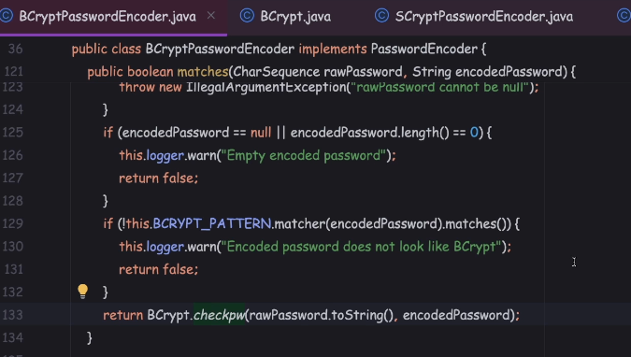

why can't we use the SCrypt and Argon2 compared to the BCrypt?

The answer is very simple, no one is stopping you in using the SCrypt and Argon2PasswordEncoder, your authentication process is going to work very similar

to the BCryptPasswordEncoder.

It's just that if you try to use the SCrypt and Argon2PasswordEncoders,

the configuration is going to be more tough, because you need to right-tune the CPU cost, memory cost, parallelization cost, so you need to find a balance, or a sweet spot, which is going to work for you by making the hacker life tough.

Since it needs three different parameters, like CPU cost, memory cost,

and parallelization, definitely, this also going to impact

your application performance during the login and registration.

So if you don't want super-slow hashing algorithm, you can use the BCryptPasswordEncoder, because it does the job, it is the recommended by Spring Security, since it is simple to use, and it also allows you to rightly balance

how much slow you want to go with the hashing process.

Maybe in future, due to the advancements that are going to happen in GPUs and CPUs, maybe BCrypt may get deprecated, but I think it may take five or six more years.

Register Demo

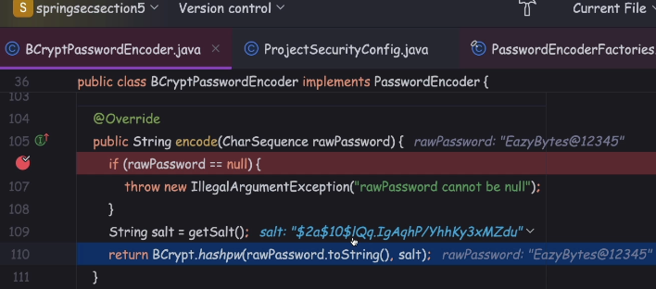

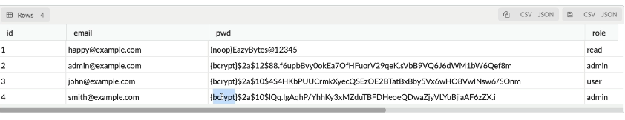

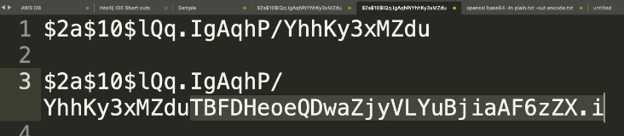

**Login demo**

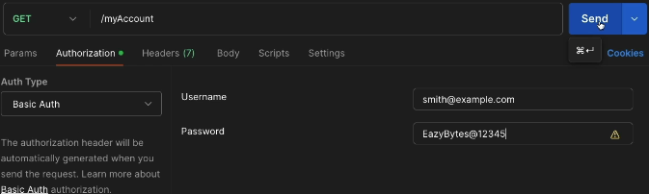

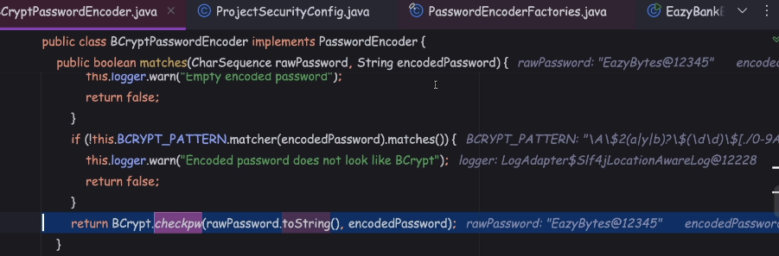

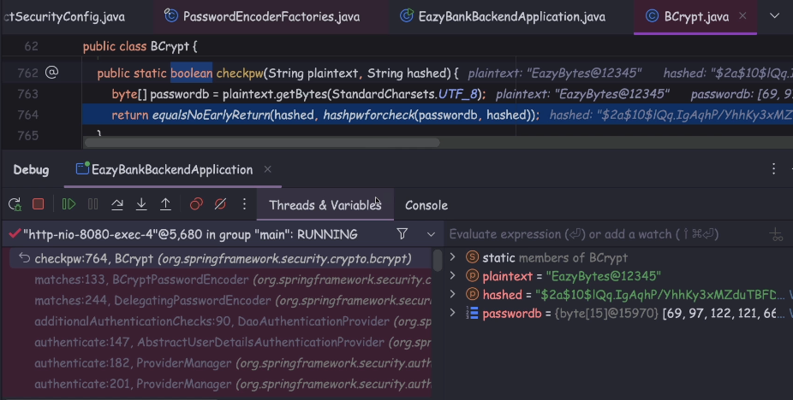

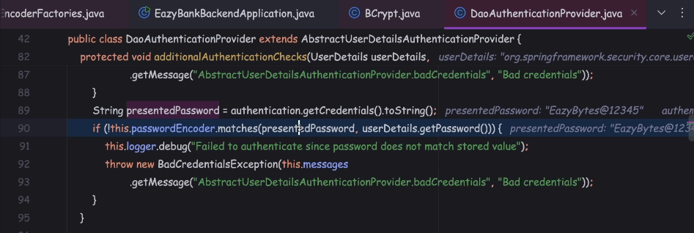

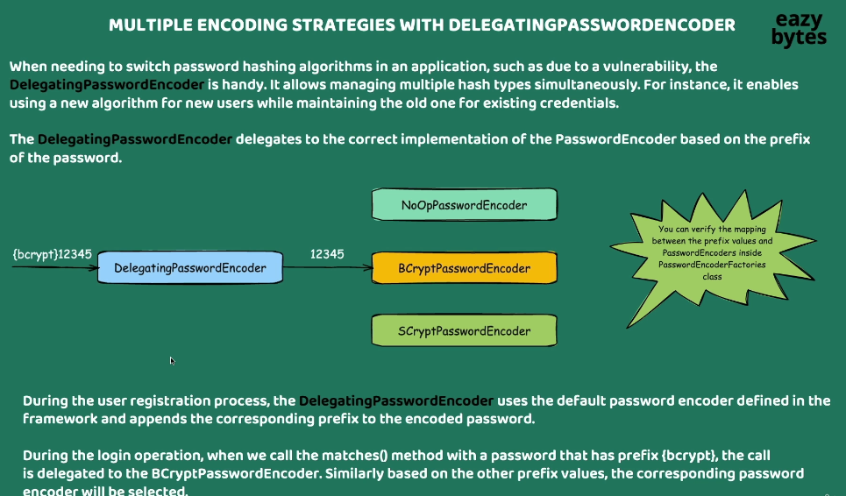

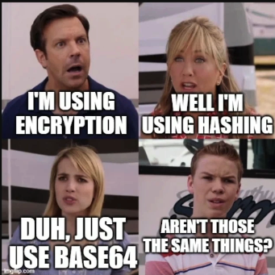

So for passwords, always go with the hashing and you know when to go for encryption. So symmetric encryption you can use in the scenarios

where you want to encrypt the data at rest and the asymmetric encryption you can use in the scenarios where you want to encrypt the data in transit.

And Basic64, you just need to use in the scenarios where you can't deal with the binary data.

Top of Form

Which of the following is defined as the process of converting data from one form to another with out any secret involved and has nothing to do with cryptography ?

**Encryption**

Top of Form

Which of the following statement related to Encoding is TRUE ?

**Encoding guarantees none of the 3 cryptographic properties of confidentiality, integrity, and authenticity because it involves no secret and is completely reversible.**

Bottom of Form

Top of Form

Which of the following statements regarding Encryption is TRUE?

**Encryption is the process of converting data to ensure its confidentiality. This transformation requires a secret, known in cryptographic terms as a "key".**

Top of Form

Which of the following statements about Hashing is correct ?

**Data once hashed using hashing technique is non-reversible.**

Top of Form

Which of the following technique is recommended while handling passwords inside web applications?

**Hashing**